**Push/pull the Docker images to nexus repository**

Steps:

1. Install docker windows from <https://docs.docker.com/docker-for-windows/install/>.
2. Click on **Docker Desktop for Windows,** exe file will get downloaded and install by clicking on next without modifying any existing settings.
3. After installing, check for docker version in Windows PowerShell.

**Docker version**

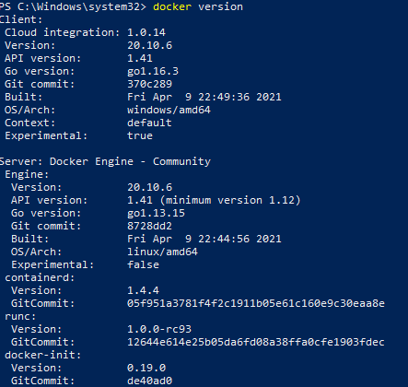

1. Login into nexus by using credentials. Provide the nexus credentials to login.

**Docker login nexus.idya4.com**



1. To provide/modify the name. we can use tag.

**Docker tag tomcat:latest nexus.idya4.com/repository/docker-repo/tomcat:5**

Docker tag existing image:version nexus.idya4.com/repository/docker-repo/image:version



1. Check for docker images.

**Docker images**

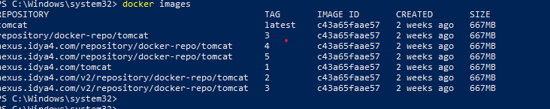

1. Push the image to nexus repository.

**Docker push nexus.idya4.com/repository/docker-repo/tomcat:5**

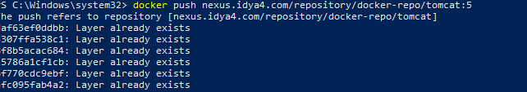

1. Confirm the image is pushed to nexus repository.

